In a survey last year 29% of Americans supported the idea that the government should make cash payments to black Americans who were descendants of slaves—twice the share that agreed in the early 2000s.

As protests have rocked America in recent weeks, the idea of reparations to atone for the atrocity of slavery,as well as to reduce the persistent gaps in income and wealth between people of different skin colours, has gained further prominence.

Joe Biden, the presumptive Democratic nominee for president, has said he wants to explore it.
On June 11th California's state lawmakers passed a bill that establishes a task-force to study and propose recommendations for reparations.

The chances of the federal government implementing such a policy seem remote. But how would such a scheme work?

As "From Here to Equality", a new book written by William Darity, a scholar on reparations at Duke University, and A. Kirsten Mullen, shows, the practicalities tend to take a back seat to philosophical arguments over whether reparations are needed in the first place.
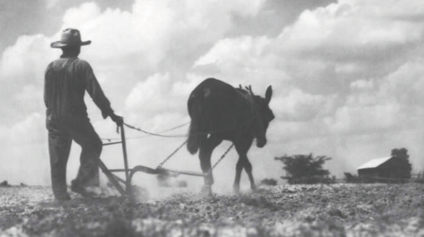
Genealogists would face the tricky task of determining who would be eligible for them.

Economists, meanwhile, would have to consider two questions: how much to pay, and how best to spend the money?

History offers a guide to the first question. Past claims for reparations have relied on the notion that people were wrongly deprived of income or property, or were unfairly forced to incur costs.
For instance, Israel calculated its claims for reparations from Germany after the second world war in part by estimating the expenditure it incurred in order to resettle Jewish victims of Nazi persecution.

An official report into America's forced relocation and incarceration of Japanese-Americans during the war reached the conclusion that they had been unfairly deprived of income and property worth $3bn (in today's prices).In 1988 the American government issued a formal apology and eventually compensated 80,000 victims.

Many scholars have tried to work out what would count as sufficient compensation for the descendants of slaves, but there is little agreement between them.

One approach is to focus on compensation promised by the Union Army to freed slaves in 1865—the value of 40 acres of land and a mule—which was never realised. The amount of cropland required to meet that commitment today has a value of about $160bn (0.7% of American GDP in 2019).
在去年的一次调查中，29%的美国人支持政府
应该向身为奴隶后裔的美国黑人支付现金——这一比例是本世纪初的两倍。
近几周的抗议活动撼动了美国，用赔款抵偿奴隶制的暴行
并减少不同肤色人群之间持续存在的收入和财富差距的这种想法更加显著。
有望成为民主党总统候选人的乔·拜登曾表示，他希望探索这一问题。
6月11日，加利福尼亚州的立法者通过了一项法案，建立一支特别小组，对赔偿进行研究，并提出建议。
联邦政府执行这项政策的机会似乎渺茫。但这样的计划如何运作呢？
杜克大学研究赔款的学者William Darity以及A. Kirsten Mullen写的一本新书《From Here to Equality》表明
针对是否需要赔偿的问题，实践性往往让位于哲学论证。
系谱专家将面临一项棘手的任务，即决定谁有资格获得赔款。
与此同时，经济学家将不得不考虑两个问题：支付多少钱，以及如何最好地使用这笔钱？
对于第一个问题，历史提供了指导。过去的索赔依赖这样一种观念：
人们被不当地剥夺了收入或财产，或者被迫承担损失。
例如，二战后，以色列通过预估重新安置纳粹受害者所需的开支
来计算其向德国提出的赔偿要求。
一份关于战争期间，美国强迫日裔美国人迁居和监禁的官方报告得出结论称，
他们被不公平地剥夺了价值30亿美元（以今天的价格计算）的收入和财产。
1988年，美国政府正式道歉，并最终向8万名受害者进行赔偿。
很多学者曾试图为奴隶后代计算出充足的赔款，但他们几乎没有达成一致。
一种方法是专注联邦军在1865年解放奴隶时所承诺的赔偿——40英亩土地和一头骡子的价值——但这从未兑现。
如今，实现这一承诺所需的耕地价值约为1600亿美元（占2019年美国GDP的0.7%）。

