经济学人:布鲁迪的假选举(1)
A landslide victory for the president's hand-picked successor
As peolple elsewhere hunkered down at home to avoid covid-19, millions in Burundi crowded into polling stations on May 20th to vote in the general election. Among the many voters were scores of dead people, activists allege. Humanrights watchdogs said that members of the ruling party, CNDD-FDD, boosted its tallies by adding the ballots of people locked up in jail-and of those who had died.
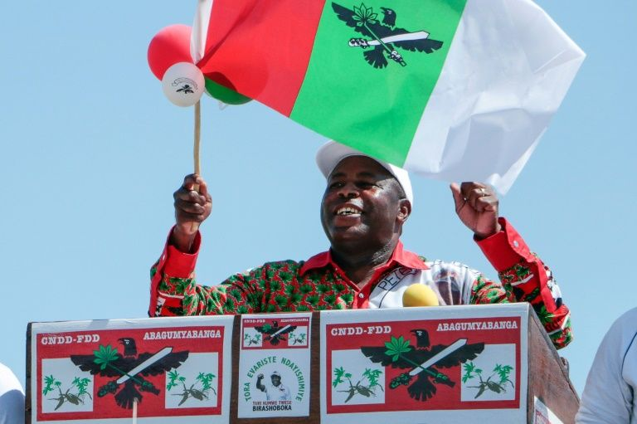
"When I saw the same person voting for the third time I complained," says one voter. He was sent packing by officials and told to "stop creating problems".
Shenanigans such as these might explain why, for instance, in Bukeye in Muramvya province 4,000 more votes were cast than there were voters on the register. Another reason could be that some boxes already had papers in them when polling stations opened, suggests Aime Magera, spokesman for the National Freedom Council (CNL), an opposition party. Few in Burundi were surprised when the ruling party's candidate, Evariste Ndayishimiye, was declared the winner with 69% of the vote. Mr Ndayishimiye, an ex-general, was handpicked by Pierre Nkurunziza, the outgoing president who has ruled since 2005. Mr Nkurunziza is no stranger to controversy. In 2015 he won a third term, despite a constitutional limit of two. (He said his first term didn't count, as he was chosen by parliament, rather than directly elected.)

总统精心挑选的继任者以压倒性优势获胜
5月20日，当其他地方的人们蜷缩在家里躲避新冠肺炎时，布隆迪数百万人涌入投票站参加大选投票。参与活动的人宣称，其中有许多选民是死人。人权监督机构说，执政党保卫民主全国委员会-保卫民主力量增加了被关在监狱里的人和死者的选票，从而提高了投票率。
一位选民说：“当我看到同一个人第三次投票时，我十分抱怨。”官员们把他打发走，叫他“别再制造麻烦了”。
诸如此类的恶作剧或许可以解释为什么，例如，在穆拉姆维亚省的布基，投票人数比登记册上的选民多出4000票。反对党国家自由委员会发言人艾梅·马格拉表示，另一个原因可能是投票站开放时，一些投票箱里已经有了选票。当执政党候选人恩达伊希米耶以69%的选票当选时，布隆迪几乎没有人感到惊讶。皮埃尔·恩库伦齐扎这位已卸任的总统自2005年一直执政，他亲手挑选了前总书记恩达伊希米耶。恩库伦齐扎对争议并不陌生。2015年，尽管宪法限制只能连任两届，但他还是赢得了第三届。（他说他的第一个任期不算数，因为他是由议会选出的，而不是直接选举产生的。）

