Even as ominous clouds of Covid-19 hang over the Indian economy, businesses are finding ways to make money.
From turmeric milk to foot pedal dispensers, several Indian companies have in recent weeks launched new products or rebranded their existing offerings with a focus to lure customers who are worried about their health and are trying to maintain social distancing during the pandemic.
For instance, on June 8, Noida-based milk products maker Mother Dairy launched a new turmeric flavoured drink, which it said helps boost immunity against the virus. "Turmeric contains curcumin, a flavonoid which supports a healthy immune response, thereby promoting general well-being," the company said in a press release.
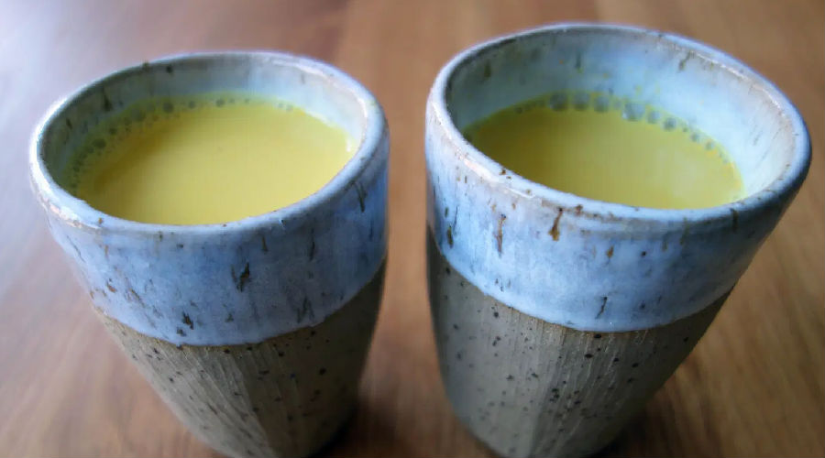
Turmeric milk, which became popular in the US a few years ago as "turmeric latte," is a traditional household beverage in India with roots dating back almost 4,000 years. Mother Dairy's move is a clever one since the product is "aimed at reviving India's old traditions while providing convenience to its consumers," says Nidhi Sinha, head of content at market research firm the Mintel Group, said.
In March, the business conglomerate Dalmia Group launched a "coronavirus preventive capsule," which, it said will help people avoid contracting Covid-19. The company also said the capsule, which comprises a melange of 15 herbs, will boost immunity and reduce inflammation in lungs.
In addition, several cafes across the country, including Chaayos, Starbucks, and Cafe Coffee Day are marketing products to highlight their immunity building benefits. "Marketers are out there with a vengeance to tweak their offerings attuned to a new want, a new desire, and a new craving," said Harish Bijoor, a branding expert and founder of the eponymous market research firm Harish Bijoor Consults.
新冠病毒的阴云笼罩着印度的经济，商人们正在寻找赚钱的门路。
从姜黄牛奶到脚踏板分配器，一些印度公司最近几周纷纷推出新产品，或者重新包装现有产品，来吸引那些担心健康问题，并且在疫情期间尽力保持社交距离的消费者。
比如，6月8日，诺伊达的乳制品制造商Mother Dairy推出了新的姜黄味饮品，并宣传说它有助于提高对抗新冠病毒的免疫力。该公司在新闻稿中说：“姜黄含有姜黄素，这是一种支持健康免疫反应的类黄酮，能改善整体健康。”
姜黄牛奶几年前在美国颇为流行，取名“姜黄拿铁”，是印度传统的家庭饮品，可以追溯到约4,000年前。市场研究公司Mintel Group内容主管Nidhi Sinha说，Mother Dairy公司此举很明智，因为这款产品“旨在恢复印度古老传统，还能为消费者提供便利。”
三月份，商业集团Dalmia Group推出了一款“冠状病毒预防胶囊”，据说能帮助人们避免感染新冠病毒。该公司也说这款胶囊的成分中含有15种药草，能增强免疫力，减少肺部炎症。
此外，全国还有几家咖啡厅，包括Chaayos、星巴克和Cafe Coffee Day，他们所销售的产品的亮点都是增强免疫力。品牌专家Harish Bijoor是同名市场研究公司Harish Bijoor Consults的创始人，他说：“市场营销人员正在努力调整他们的产品，以满足新需要、新要求和新渴望。”

