2019年6月浙江高考英语概要写作
Name:_______ Class:________
第二节 概要写作(满分25分)
阅读下面短文，根据其内容写一篇60词左右的内容概要。
Parents everywhere praise their kids. Jenn Berman, author of The A to Z Guide to Raising Happy and Confident Kids, says, “We've gone to the opposite extreme of a few decades ago when parents tended to be more strict.” By giving kids a lot of praise, parents think they’re building their children's confidence, when, in fact, it may be just the opposite. Too much praise can backfire and, when given in a way that's insincere, make kids afraid to try new things or take a risk for fear of not being able to stay on top where their parents' praise has put them.
Still, don't go too far in the other direction. Not giving enough praise can be just as damaging as giving too much. Kids will feel like they’re not good enough or that you don’t care and, as a result, may see no point in trying hard for their accomplishments.
So what is the right amount of praise? Experts say that the quality of praise is more important than the quantity. If praise is sincere and focused on the effort not the outcome, you can give it as often as your child does something that deserves a verbal reward. “We should especially recognize our children’s efforts to push themselves and work hard to achieve a goal,” says Donahue, author of Parenting Without Fear:Letting Go of Worry and Focusing on What Really Matters.“One thing to remember is that it’s the process not the end product that matters.”
Your son may not be the best basketball player on his team. But if he's out there every day and playing hard, you should praise his effort regardless of whether his team wins or loses. Praising the effort and not the outcome can also mean recognizing your child when she has worked hard to clean the yard, cook dinner, or finish a book report. But whatever it is, praise should be given on a case-by-case basis and be proportionate(相称的）to the amount of effort your child has put into it.

________________________________________________________________________________________________________________________________________________________________________________________________________________________________________________________________________________________________________________________________________________________________________________________________________________________________________________________________________________________________________________________________________________________________________________________________________________________________________________________
______________________________________________________________________________________________________________________________________________________________

概写步骤
第一步：通读理解全文，了解文章结构，明确各段落之间的逻辑关系，提取全文中心词(尤其是名词与动词)。
第二步：细读原文，划出各段的主题句与关键词，关键词以动词与名词为主，涵盖段落全部要点与次要点。
第三步：根据所划内容，结合理解，理清句内逻辑关系，合成句子。可用中文概括出段落大意，然后用一句话翻译出来(合理利用原词)。
第四步：通读修改。修改是一个重要的环节，要考虑连接词的使用；高级词汇的替换；句式的多样；语法是否正确以及字数的多少。
第五步：用自信衡水体抄到试卷上，力求清楚美观。
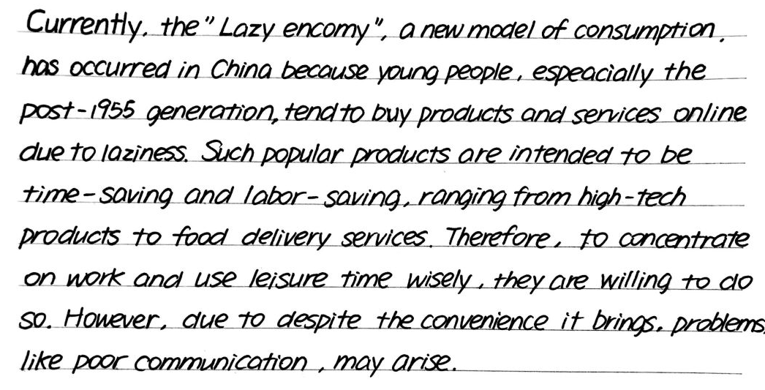
请认真模仿衡水体：
_________________________________________________________________________________________________________________________________________________________________________________________________________________________________________________________________________________________________________________________________________________________________________________________________________________________________________________________________________________________________________________________________________________________________________
______________________________________________________________________________________________________________________________________________________________

2019.6浙江高考英语概要写作范文：
范文一：
一、关键词句已在原文标出，结合理解，用中文概括出一句话并译成英文。
1如今，父母总是给孩子们大多的赞扬，希望增强他们的自信，但是这可能会产生相反的效果。
Nowadays, parents tend to offer considerable praise to their children, hoping to boost their confidence, but it may produce the opposite effect.
2 然而，父母不表扬同样有损他们的自信心。
However, no praise from parents also does harm to their self-confidence.
3 因此，专家认为，应该因为努力过程而赞扬孩子，而不是因为事情的结果赞扬孩子。
Therefore, experts claim that sincere praise should be given for the process not for the result.
4 同时，如果孩子尽责做事，确实值得赞扬。总之，你能给的赞扬程度应取决于他们的努力程度。
Meanwhile, kids do deserve praise if they strive to do their duty. Anyway, the amount of praise you have depends on how hard they work.
二、范文草稿（删减与替换过程）
Contrary to what parents did in the past, Nowadays, parents today (tend to) offer considerate praise to their children, hoping to boost their confidence, but it can have (produce) the opposite effect. However, no praise from parents means going to the other extreme, which also does harm to their self-confidence.Therefore, experts state(claim) that sincere praise should be given to kids for the process not for the result. Meanwhile, kids do deserve praise if they make efforts (strive) to do their duty. Anyway, the amount of praise you give (have) depends on how hard they work.
- 范文
Nowadays, parents tend to offer considerable praise to their children, hoping to boost their confidence, but it may produce the opposite effect. However, no praise from parents also does harm to their self-confidence. Therefore, experts claim that sincere praise should be given for the process not for the result. Meanwhile, kids do deserve praise if they strive to do their duty. Anyway, the amount of praise you have depends on how hard they work.
范文二
Parents praise their children to promote their confidence, but the overpraise may lead to an opposite effect. However, inadequate praise is also harmful as it deprive kids of motivation. Actually, what really matters is the quality of praise, which should be sincere and concentrate on process rather than result. Praise offers encouragement and recognition, while it should be based on the facts and correspond with the effort.
范文三
Excessive or insincere praise, though supposed to build kids’ confidence, can actually turn them into withering violets.In like manner, insufficient praise also impairs kids’ confidence, self-esteem, and even motivation. Therefore, a sincere, fact-based and effort-oriented compliment is superior to one that merely focuses on the outcomes. So recognize your child by praising his efforts even if he/ she is just ordinary. He/she deserves it.

