M2U1 Project
Work sheet
Telling about an unexplained mystery

Step1. Lead-in
The most beautiful thing we can experience is the mysterious. It is the source of all true art and science.
------Albert Einstein
Give some examples of the unexplained:UFO, ________,________,
________,________,etc

Step2.Reading
Yeti, Bigfoot and the Wild Man of Shennongjia
A video from CCTV
Q:In some areas of the world there have been reports of Yetis. Do you believe that such a creature exists?

Some background information is given on the PPT.

Task1: Watch the video of the text and fill in the tables

What they are called | Where they were seen | Decriptions/what they look like
Yeti |  | large ,hairy animal that walks on two feet like a _______ _______
Bigfoot |  | The _______ of Bigfoot look like those of the Yeti
Wild Man of Shennongjia |  | It is _______ to Yeti and  Bigfoot,who can move with amazing _______and _______.
Task2. Detailed descriptions of the wild creature(para2).
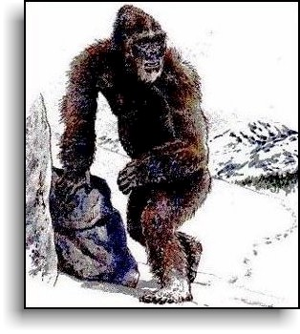

Task3.Analyze the outline of the passage
Para1.
Sightings of Yetis are _______.
Para2-4.
Witnesses give________ descriptions of the wild creature.
Para5.
An American scientist’s__________.
Para6.
The hope for the________of the mystery.

Step3.Writing

To write a story about an unexplained mystery, we need to think about:
- an interesting and attractive title
- an attractive beginning
- some details of the story with some pictures or photos
- what scientists or people think about the mystery
- an open ending of the story

Step4.Telling and presenting

Tell a story about an unexplained mystery.
- Be confident,be louder and cooperate properly.
- Use your imagination and be creative.
- Present your story in different forms.

