三分之二的美国人认为特朗普加剧了种族紧张局势
A majority of Americans feels that President Trump has made race relations worse since George Floyd was killed by Minneapolis police. That's according to a new NPR/PBS NewsHour/Marist poll taken this week after demonstrations spread around the country. Joining us now to talk about those numbers is NPR's Domenico Montanaro. Hi, Domenico.
DOMENICO MONTANARO, BYLINE: Hey there, Sarah.
MCCAMMON: So what are the big takeaways?
MONTANARO: Well, you named one of them. I mean, two-thirds of Americans think Trump has increased racial tensions in this country after George Floyd's death. And Trump is suffering politically because of it. His job approval rating is at 41%. It's down a couple points since March, but about where it's been. But his disapproval rating, the number of people disapproving of the job he's doing, is at 55%, almost the worst of his presidency.
And what's striking about this is the intensity of that disapproval. Almost half the country, 47%, now say they strongly disapprove of the job the president is doing. Independents strongly disapproving have shot up 10 points since March. And all that's put Trump in a big hole against Joe Biden. Biden leads Trump in a head-to-head in the general election now 50 to 43. And the poll shows Biden making inroads with key groups, like independents, whites, women and people who live in the suburbs in particular.
MCCAMMON: Let's dig a little more deeply into what people think about the president's handling of racial tensions since Floyd's death. You said two-thirds see him as increasing tensions, but how does that cut across partisan and racial lines?
MONTANARO: Well, about 9 in 10 Democrats and African Americans think he's increased racial tension, as do almost three-quarters of independents and 63% of whites. Forty-one percent of Republicans say he's decreased tensions. But, you know, the pollsters say that they found it pretty significant that given how much Republicans have lined up in lockstep with Trump that almost 6 in 10 of them believe that he's either increased tensions or that they're not sure if he has. By the way, between Trump and Biden, people say Biden would be better to handle race relations in the country by a substantial margin — 52% to 34%.
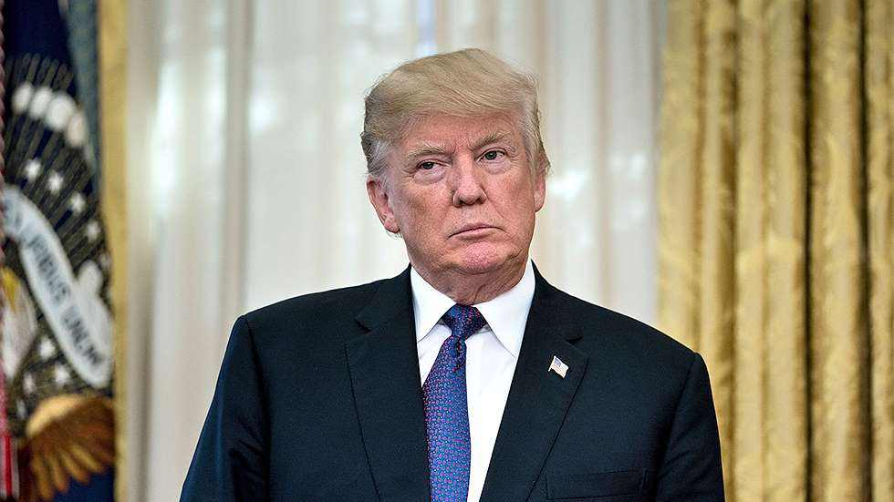
MCCAMMON: And this, of course, comes against the backdrop of massive nationwide protests at the death of George Floyd. What are Americans saying about the protests?
MONTANARO: Well, you know, Trump's had a lot of tough talk about the demonstrators obviously. But Americans as a whole don't agree with his characterizations of them. Overall, 62% that we talked to say that they view the demonstrations as mostly legitimate protests as opposed to people acting unlawfully. That includes 87% of Democrats, 65% of independents. The exception here is Republicans. Fifty-nine percent of Republicans think the demonstrators are mostly acting unlawfully.
Now it really should be noted, though, that these numbers are a really big sea change from the 1960s when most people had an unfavorable view of civil rights demonstrations and thought that they would hurt African Americans' goal of racial equality. And when it comes to police in our poll, a majority still have at least a fair amount or a great deal of confidence that their local police treat black and white people equally. But I have to tell you, that percentage is down 8 points since Marist last asked the question in 2014. And there's a huge racial divide, with almost half of black Americans saying that they have very little to no confidence that the police will treat everyone equally.
MCCAMMON: Lots of numbers there, numbers to watch in the coming months. Thanks so much, Domenico.
MONTANARO: You're welcome, Sarah.
MCCAMMON: That's NPR's Domenico Montanaro.

参考译文：
大多数美国人认为，自乔治·弗洛伊德被明尼阿波利斯市警察杀害之后，特朗普总统令种族关系进一步恶化。这是美国公共广播电台（简称NPR）、公共广播公司《新闻一小时》与马里斯特舆情调研所联合开展的最新民调的结果，该民调于本周在示威活动蔓延至全美后进行。下面我们将连线NPR新闻的多梅尼克·蒙塔纳罗，请他介绍具体民调结果。你好，多梅尼克。
多梅尼克·蒙塔纳罗连线：你好，萨拉。
麦卡蒙：有哪些重点内容？
蒙塔纳罗：你刚提到了其中一个重点。即三分之二的美国人认为，在乔治·弗洛伊德死亡之后，特朗普加剧了美国的种族紧张局势。特朗普因此而在政治上蒙受损失。他的工作支持率为41%。这一数字自三月以来下降了几个百分点，基本保持不变。但他的不支持率——即不支持其工作的人数——达到了55%，几乎是他总统任期内最糟糕的一次。
最引人注目的是不支持的强烈程度。现在47%的人，即美国近一半人表示，他们强烈反对总统的工作。自3月份以来，持强烈反对态度的无党派人士数量飙升了10个百分点。所有这些都让特朗普在与乔·拜登竞争时陷入极为尴尬的处境。目前拜登在正面交锋的大选中以50%比43%领先于特朗普。民调显示，拜登争取到了一些关键群体的支持，比如独立人士，白人，女性，尤其是生活在郊区的人。
麦卡蒙：我们来深入探讨一下人们对弗洛伊德死后总统处理种族紧张关系的看法。你刚提到，三分之二的人认为他加剧了紧张局势，但这是如何跨越党派和种族界限的？
蒙塔纳罗：约90%的民主党人和非洲裔美国人认为他加剧了种族紧张局势，持这种观点的独立人士和白人的比例分别为近四分之三和63%。41%的共和党人认为特朗普缓和了紧张局势。但民间调查员表示，他们发现非常重要的一点是，考虑到共和党人与特朗普步调一致的程度，竟然有近60%的共和党人要么认为他加剧了紧张局势，要么不能确定他是否加剧了紧张。顺便提一下，在特朗普和拜登之间，52%的人认为拜登能更好地处理美国的种族关系，而支持特朗普的人只有34%，显然，拜登在这一问题上优势明显。
麦卡蒙：当然，民调是在乔治·弗洛伊德之死引发大规模全国性抗议的背景下进行的。美国人对抗议有何看法？
蒙塔纳罗：特朗普显然对示威者发表了很多强硬的言论。但整体上来说美国人不同意他对示威者的描述。总的来说，62%的受访者表示，他们认为示威大多是合法抗议，而不是人们的非法行为。这包括87%的民主党人，65%的独立人士。共和党人是例外。59%的共和党人认为示威者的大多数行为是非法的。
不过应该指出的是，这些数字较20世纪60年代发生了重大变化，当时大多数人对民权示威持负面看法，人们认为这些示威会损害非洲裔美国人的种族平等目标。至于警察，我们的民调显示，大多数人仍然有相当大的信心或极大的信心，认为当地警察平等对待黑人和白人。但我必须要说，持这种观点的比例较马里斯特调研所上次在2014年调查这一问题时下降了8个百分点。这个问题存在严重的种族分歧，近一半美国黑人认为他们对警察平等对待所有人几乎没有信心。
麦卡蒙：这涉及很多数据，未来几个月还有数据要观察。非常谢谢你，多梅尼克。
蒙塔纳罗：不客气，萨拉。
麦卡蒙：以上是NPR新闻的多梅尼克·蒙塔纳罗带来的报道。

