江苏省仪征中学2021-2022学年度第一学期高一物理学科导学案
专题 追及与相遇问题
研制人：熊小燕 审核人：邱勇
班级：____________姓名：____________学号：________授课日期：2021.9.27
本课在课程标准中的表述：能用匀变速直线运动公式结合图像，找到追及相遇问题的速度、位移、时间关系解决实际问题.
[学习目标]
1．会分析追及相遇问题，找到问题的临界点．
2．会根据两者速度关系和位移关系列方程解决追及相遇问题．
[课堂导思]
例1：一辆值勤的警车停在公路边，当警员发现在他前面x₀＝13 m远处以v₀＝8 m/s的速度匀速向前行驶的货车有违章行为时，决定前去追赶，经t₀＝2.5 s，警车发动起来，以加速度a＝2 m/s²做匀加速直线运动，求：
(1)警车发动后追上违章的货车所用的时间t；
(2)在警车追上货车之前，两车间的最大距离Δx_{m}.

针对训练：汽车以20 m/s的速度在平直公路上行驶时，制动后40 s停下来．现在同一平直公路上以20 m/s的速度行驶时发现前方200 m处有一货车以6 m/s的速度同向匀速行驶，司机立即制动，则：
(1)求汽车刹车时的加速度大小；
(2)是否发生撞车事故？若发生撞车事故，在何时发生？若没有撞车，两车最近距离为多少？

INCLUDEPICTURE "G:\\2020\\同步\\物理\\人教必修第一册（新教材）\\全书完整的Word版文档\\左括.tif" \* MERGEFORMATINET INCLUDEPICTURE "\\\\杨营\\g\\2020\\同步\\物理\\人教必修第一册（新教材）\\全书完整的Word版文档\\左括.tif" \* MERGEFORMATINET INCLUDEPICTURE "\\\\杨营\\g\\2020\\同步\\物理\\人教必修第一册（新教材）\\全书完整的Word版文档\\左括.tif" \* MERGEFORMATINET INCLUDEPICTURE "../../../../../徐婷/Desktop/9.1-9.13高一物理网课材料/2.4自由落体运动/左括.tif" \* MERGEFORMAT INCLUDEPICTURE "../../../左括.tif" \* MERGEFORMAT INCLUDEPICTURE "../../../左括.tif" \* MERGEFORMAT INCLUDEPICTURE "../../../左括.tif" \* MERGEFORMAT INCLUDEPICTURE "../../../左括.tif" \* MERGEFORMAT INCLUDEPICTURE "../../../左括.tif" \* MERGEFORMAT INCLUDEPICTURE "../../../左括.tif" \* MERGEFORMAT INCLUDEPICTURE "../../../左括.tif" \* MERGEFORMAT INCLUDEPICTURE "../../../左括.tif" \* MERGEFORMAT INCLUDEPICTURE "../../../左括.tif" \* MERGEFORMAT INCLUDEPICTURE "../../../左括.tif" \* MERGEFORMAT INCLUDEPICTURE "../../../左括.tif" \* MERGEFORMAT INCLUDEPICTURE "../../../左括.tif" \* MERGEFORMAT INCLUDEPICTURE "../../../左括.tif" \* MERGEFORMAT INCLUDEPICTURE "../../导学案/新建文件夹/左括.tif" \* MERGEFORMAT INCLUDEPICTURE "../左括.tif" \* MERGEFORMAT INCLUDEPICTURE "左括.tif" \* MERGEFORMAT 导思总结 INCLUDEPICTURE "G:\\2020\\同步\\物理\\人教必修第一册（新教材）\\全书完整的Word版文档\\右括.tif" \* MERGEFORMATINET INCLUDEPICTURE "\\\\杨营\\g\\2020\\同步\\物理\\人教必修第一册（新教材）\\全书完整的Word版文档\\右括.tif" \* MERGEFORMATINET INCLUDEPICTURE "\\\\杨营\\g\\2020\\同步\\物理\\人教必修第一册（新教材）\\全书完整的Word版文档\\右括.tif" \* MERGEFORMATINET INCLUDEPICTURE "../../../../../徐婷/Desktop/9.1-9.13高一物理网课材料/2.4自由落体运动/右括.tif" \* MERGEFORMAT INCLUDEPICTURE "../../../右括.tif" \* MERGEFORMAT INCLUDEPICTURE "../../../右括.tif" \* MERGEFORMAT INCLUDEPICTURE "../../../右括.tif" \* MERGEFORMAT INCLUDEPICTURE "../../../右括.tif" \* MERGEFORMAT INCLUDEPICTURE "../../../右括.tif" \* MERGEFORMAT INCLUDEPICTURE "../../../右括.tif" \* MERGEFORMAT INCLUDEPICTURE "../../../右括.tif" \* MERGEFORMAT INCLUDEPICTURE "../../../右括.tif" \* MERGEFORMAT INCLUDEPICTURE "../../../右括.tif" \* MERGEFORMAT INCLUDEPICTURE "../../../右括.tif" \* MERGEFORMAT INCLUDEPICTURE "../../../右括.tif" \* MERGEFORMAT INCLUDEPICTURE "../../../右括.tif" \* MERGEFORMAT INCLUDEPICTURE "../../../右括.tif" \* MERGEFORMAT INCLUDEPICTURE "../../导学案/新建文件夹/右括.tif" \* MERGEFORMAT INCLUDEPICTURE "../右括.tif" \* MERGEFORMAT INCLUDEPICTURE "右括.tif" \* MERGEFORMAT
1．分析追及问题的注意事项
(1)要抓住一个条件，两个关系：_____________________________________________________
________________________________________________________________________________
(2)若被追赶的物体做匀减速运动，一定要注意：_______________________________________
2．解题基本思路和方法：___________________________________________________________
________________________________________________________________________________
________________________________________________________________________________
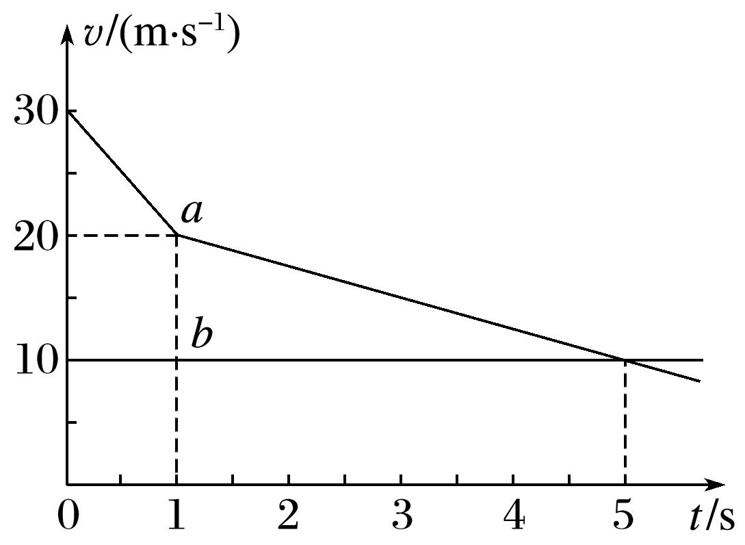
例2：一辆小汽车以30 m/s的速度匀速行驶在高速公路上，突然发现正前方30 m处有一辆大卡车以10 m/s的速度同方向匀速行驶，小汽车紧急刹车，刹车过程中刹车失灵．如图所示，图线a、b分别为小汽车和大卡车的v－t图像(忽略刹车反应时间)，以下说法正确的是( )
A．因刹车失灵前小汽车已减速，故不会发生追尾事故
B．在t＝3 s时发生追尾事故
C．在t＝5 s时发生追尾事故
D．若紧急刹车时两车相距40 m，则不会发生追尾事故且两车最近时相距10 m

INCLUDEPICTURE "G:\\2020\\同步\\物理\\人教必修第一册（新教材）\\全书完整的Word版文档\\左括.tif" \* MERGEFORMATINET INCLUDEPICTURE "G:\\2020\\同步\\物理\\人教必修第一册（新教材）\\全书完整的Word版文档\\左括.tif" \* MERGEFORMATINET INCLUDEPICTURE "\\\\杨营\\g\\2020\\同步\\物理\\人教必修第一册（新教材）\\全书完整的Word版文档\\左括.tif" \* MERGEFORMATINET INCLUDEPICTURE "\\\\杨营\\g\\2020\\同步\\物理\\人教必修第一册（新教材）\\全书完整的Word版文档\\左括.tif" \* MERGEFORMATINET INCLUDEPICTURE "../../../../../徐婷/Desktop/9.1-9.13高一物理网课材料/2.4自由落体运动/左括.tif" \* MERGEFORMAT INCLUDEPICTURE "../../../左括.tif" \* MERGEFORMAT INCLUDEPICTURE "../../../左括.tif" \* MERGEFORMAT INCLUDEPICTURE "../../../左括.tif" \* MERGEFORMAT INCLUDEPICTURE "../../../左括.tif" \* MERGEFORMAT INCLUDEPICTURE "../../../左括.tif" \* MERGEFORMAT INCLUDEPICTURE "../../../左括.tif" \* MERGEFORMAT INCLUDEPICTURE "../../../左括.tif" \* MERGEFORMAT INCLUDEPICTURE "../../../左括.tif" \* MERGEFORMAT INCLUDEPICTURE "../../../左括.tif" \* MERGEFORMAT INCLUDEPICTURE "../../../左括.tif" \* MERGEFORMAT INCLUDEPICTURE "../../../左括.tif" \* MERGEFORMAT INCLUDEPICTURE "../../../左括.tif" \* MERGEFORMAT INCLUDEPICTURE "../../../左括.tif" \* MERGEFORMAT INCLUDEPICTURE "../../导学案/新建文件夹/左括.tif" \* MERGEFORMAT INCLUDEPICTURE "../左括.tif" \* MERGEFORMAT INCLUDEPICTURE "左括.tif" \* MERGEFORMAT 总结提升 INCLUDEPICTURE "G:\\2020\\同步\\物理\\人教必修第一册（新教材）\\全书完整的Word版文档\\右括.tif" \* MERGEFORMATINET INCLUDEPICTURE "\\\\杨营\\g\\2020\\同步\\物理\\人教必修第一册（新教材）\\全书完整的Word版文档\\右括.tif" \* MERGEFORMATINET INCLUDEPICTURE "\\\\杨营\\g\\2020\\同步\\物理\\人教必修第一册（新教材）\\全书完整的Word版文档\\右括.tif" \* MERGEFORMATINET INCLUDEPICTURE "../../../../../徐婷/Desktop/9.1-9.13高一物理网课材料/2.4自由落体运动/右括.tif" \* MERGEFORMAT INCLUDEPICTURE "../../../右括.tif" \* MERGEFORMAT INCLUDEPICTURE "../../../右括.tif" \* MERGEFORMAT INCLUDEPICTURE "../../../右括.tif" \* MERGEFORMAT INCLUDEPICTURE "../../../右括.tif" \* MERGEFORMAT INCLUDEPICTURE "../../../右括.tif" \* MERGEFORMAT INCLUDEPICTURE "../../../右括.tif" \* MERGEFORMAT INCLUDEPICTURE "../../../右括.tif" \* MERGEFORMAT INCLUDEPICTURE "../../../右括.tif" \* MERGEFORMAT INCLUDEPICTURE "../../../右括.tif" \* MERGEFORMAT INCLUDEPICTURE "../../../右括.tif" \* MERGEFORMAT INCLUDEPICTURE "../../../右括.tif" \* MERGEFORMAT INCLUDEPICTURE "../../../右括.tif" \* MERGEFORMAT INCLUDEPICTURE "../../../右括.tif" \* MERGEFORMAT INCLUDEPICTURE "../../导学案/新建文件夹/右括.tif" \* MERGEFORMAT INCLUDEPICTURE "../右括.tif" \* MERGEFORMAT INCLUDEPICTURE "右括.tif" \* MERGEFORMAT
追及与相遇问题常见情况
1．速度小者追速度大者
类型 | 图像 | 说明
匀加速  追匀速 | INCLUDEPICTURE "G:\\2020\\同步\\物理\\人教必修第一册（新教材）\\全书完整的Word版文档\\2-87.TIF" \* MERGEFORMATINET INCLUDEPICTURE "G:\\2020\\同步\\物理\\人教必修第一册（新教材）\\全书完整的Word版文档\\2-87.TIF" \* MERGEFORMATINET INCLUDEPICTURE "../../../2-87.TIF" \* MERGEFORMAT INCLUDEPICTURE "../../../2-87.TIF" \* MERGEFORMAT INCLUDEPICTURE "../../../2-87.TIF" \* MERGEFORMAT INCLUDEPICTURE "../../../2-87.TIF" \* MERGEFORMAT INCLUDEPICTURE "../../../2-87.TIF" \* MERGEFORMAT INCLUDEPICTURE "../../../2-87.TIF" \* MERGEFORMAT INCLUDEPICTURE "../../../2-87.TIF" \* MERGEFORMAT INCLUDEPICTURE "../../../2-87.TIF" \* MERGEFORMAT INCLUDEPICTURE "../../导学案/新建文件夹/2-87.TIF" \* MERGEFORMAT INCLUDEPICTURE "../2-87.TIF" \* MERGEFORMAT INCLUDEPICTURE "2-87.TIF" \* MERGEFORMAT 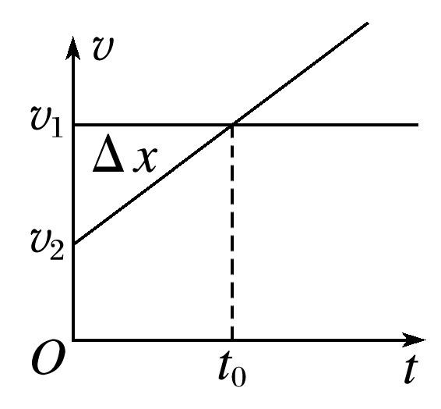
匀速追  匀减速 | INCLUDEPICTURE "G:\\2020\\同步\\物理\\人教必修第一册（新教材）\\全书完整的Word版文档\\2-88.TIF" \* MERGEFORMATINET INCLUDEPICTURE "G:\\2020\\同步\\物理\\人教必修第一册（新教材）\\全书完整的Word版文档\\2-88.TIF" \* MERGEFORMATINET INCLUDEPICTURE "../../../2-88.TIF" \* MERGEFORMAT INCLUDEPICTURE "../../../2-88.TIF" \* MERGEFORMAT INCLUDEPICTURE "../../../2-88.TIF" \* MERGEFORMAT INCLUDEPICTURE "../../../2-88.TIF" \* MERGEFORMAT INCLUDEPICTURE "../../../2-88.TIF" \* MERGEFORMAT INCLUDEPICTURE "../../../2-88.TIF" \* MERGEFORMAT INCLUDEPICTURE "../../../2-88.TIF" \* MERGEFORMAT INCLUDEPICTURE "../../../2-88.TIF" \* MERGEFORMAT INCLUDEPICTURE "../../导学案/新建文件夹/2-88.TIF" \* MERGEFORMAT INCLUDEPICTURE "../2-88.TIF" \* MERGEFORMAT INCLUDEPICTURE "2-88.TIF" \* MERGEFORMAT 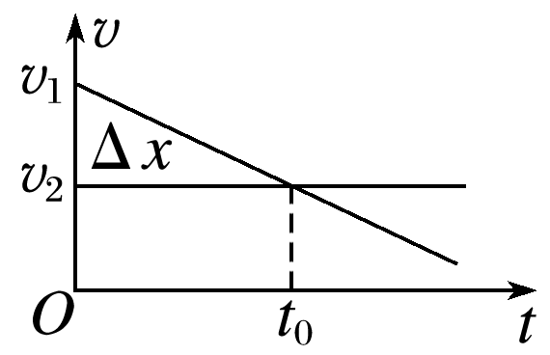
匀加速追  匀减速 | INCLUDEPICTURE "G:\\2020\\同步\\物理\\人教必修第一册（新教材）\\全书完整的Word版文档\\2-89.TIF" \* MERGEFORMATINET INCLUDEPICTURE "G:\\2020\\同步\\物理\\人教必修第一册（新教材）\\全书完整的Word版文档\\2-89.TIF" \* MERGEFORMATINET INCLUDEPICTURE "../../../2-89.TIF" \* MERGEFORMAT INCLUDEPICTURE "../../../2-89.TIF" \* MERGEFORMAT INCLUDEPICTURE "../../../2-89.TIF" \* MERGEFORMAT INCLUDEPICTURE "../../../2-89.TIF" \* MERGEFORMAT INCLUDEPICTURE "../../../2-89.TIF" \* MERGEFORMAT INCLUDEPICTURE "../../../2-89.TIF" \* MERGEFORMAT INCLUDEPICTURE "../../../2-89.TIF" \* MERGEFORMAT INCLUDEPICTURE "../../../2-89.TIF" \* MERGEFORMAT INCLUDEPICTURE "../../导学案/新建文件夹/2-89.TIF" \* MERGEFORMAT INCLUDEPICTURE "../2-89.TIF" \* MERGEFORMAT INCLUDEPICTURE "2-89.TIF" \* MERGEFORMAT 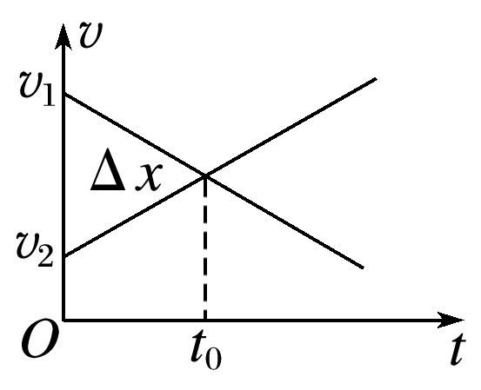

2．速度大者追速度小者
类型 | 图像 | 说明
匀减速  追匀速 | INCLUDEPICTURE "G:\\2020\\同步\\物理\\人教必修第一册（新教材）\\全书完整的Word版文档\\2-90.TIF" \* MERGEFORMATINET INCLUDEPICTURE "G:\\2020\\同步\\物理\\人教必修第一册（新教材）\\全书完整的Word版文档\\2-90.TIF" \* MERGEFORMATINET INCLUDEPICTURE "../../../2-90.TIF" \* MERGEFORMAT INCLUDEPICTURE "../../../2-90.TIF" \* MERGEFORMAT INCLUDEPICTURE "../../../2-90.TIF" \* MERGEFORMAT INCLUDEPICTURE "../../../2-90.TIF" \* MERGEFORMAT INCLUDEPICTURE "../../../2-90.TIF" \* MERGEFORMAT INCLUDEPICTURE "../../../2-90.TIF" \* MERGEFORMAT INCLUDEPICTURE "../../../2-90.TIF" \* MERGEFORMAT INCLUDEPICTURE "../../../2-90.TIF" \* MERGEFORMAT INCLUDEPICTURE "../../导学案/新建文件夹/2-90.TIF" \* MERGEFORMAT INCLUDEPICTURE "../2-90.TIF" \* MERGEFORMAT INCLUDEPICTURE "2-90.TIF" \* MERGEFORMAT 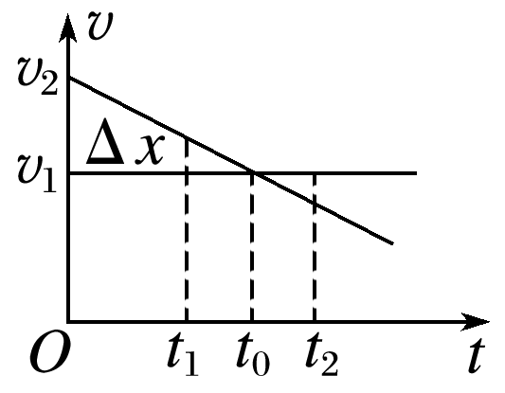
匀速追  匀加速 | INCLUDEPICTURE "G:\\2020\\同步\\物理\\人教必修第一册（新教材）\\全书完整的Word版文档\\2-91.TIF" \* MERGEFORMATINET INCLUDEPICTURE "G:\\2020\\同步\\物理\\人教必修第一册（新教材）\\全书完整的Word版文档\\2-91.TIF" \* MERGEFORMATINET INCLUDEPICTURE "../../../2-91.TIF" \* MERGEFORMAT INCLUDEPICTURE "../../../2-91.TIF" \* MERGEFORMAT INCLUDEPICTURE "../../../2-91.TIF" \* MERGEFORMAT INCLUDEPICTURE "../../../2-91.TIF" \* MERGEFORMAT INCLUDEPICTURE "../../../2-91.TIF" \* MERGEFORMAT INCLUDEPICTURE "../../../2-91.TIF" \* MERGEFORMAT INCLUDEPICTURE "../../../2-91.TIF" \* MERGEFORMAT INCLUDEPICTURE "../../../2-91.TIF" \* MERGEFORMAT INCLUDEPICTURE "../../导学案/新建文件夹/2-91.TIF" \* MERGEFORMAT INCLUDEPICTURE "../2-91.TIF" \* MERGEFORMAT INCLUDEPICTURE "2-91.TIF" \* MERGEFORMAT 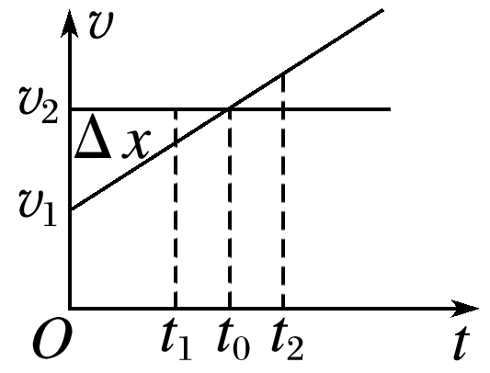
匀减速  追匀  加速 | INCLUDEPICTURE "G:\\2020\\同步\\物理\\人教必修第一册（新教材）\\全书完整的Word版文档\\2-92.TIF" \* MERGEFORMATINET INCLUDEPICTURE "G:\\2020\\同步\\物理\\人教必修第一册（新教材）\\全书完整的Word版文档\\2-92.TIF" \* MERGEFORMATINET INCLUDEPICTURE "../../../2-92.TIF" \* MERGEFORMAT INCLUDEPICTURE "../../../2-92.TIF" \* MERGEFORMAT INCLUDEPICTURE "../../../2-92.TIF" \* MERGEFORMAT INCLUDEPICTURE "../../../2-92.TIF" \* MERGEFORMAT INCLUDEPICTURE "../../../2-92.TIF" \* MERGEFORMAT INCLUDEPICTURE "../../../2-92.TIF" \* MERGEFORMAT INCLUDEPICTURE "../../../2-92.TIF" \* MERGEFORMAT INCLUDEPICTURE "../../../2-92.TIF" \* MERGEFORMAT INCLUDEPICTURE "../../导学案/新建文件夹/2-92.TIF" \* MERGEFORMAT INCLUDEPICTURE "../2-92.TIF" \* MERGEFORMAT INCLUDEPICTURE "2-92.TIF" \* MERGEFORMAT 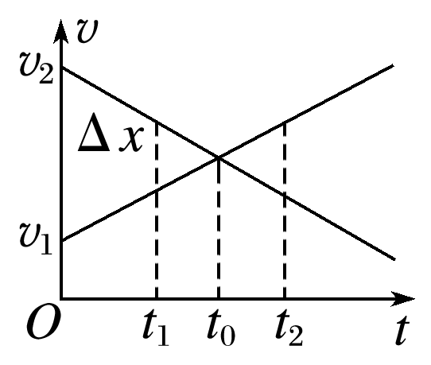

INCLUDEPICTURE "G:\\2020\\同步\\物理\\人教必修第一册（新教材）\\全书完整的Word版文档\\左括.tif" \* MERGEFORMATINET INCLUDEPICTURE "\\\\杨营\\g\\2020\\同步\\物理\\人教必修第一册（新教材）\\全书完整的Word版文档\\左括.tif" \* MERGEFORMATINET INCLUDEPICTURE "\\\\杨营\\g\\2020\\同步\\物理\\人教必修第一册（新教材）\\全书完整的Word版文档\\左括.tif" \* MERGEFORMATINET INCLUDEPICTURE "../../../../../徐婷/Desktop/9.1-9.13高一物理网课材料/2.4自由落体运动/左括.tif" \* MERGEFORMAT INCLUDEPICTURE "../../../左括.tif" \* MERGEFORMAT INCLUDEPICTURE "../../../左括.tif" \* MERGEFORMAT INCLUDEPICTURE "../../../左括.tif" \* MERGEFORMAT INCLUDEPICTURE "../../../左括.tif" \* MERGEFORMAT INCLUDEPICTURE "../../../左括.tif" \* MERGEFORMAT INCLUDEPICTURE "../../../左括.tif" \* MERGEFORMAT INCLUDEPICTURE "../../../左括.tif" \* MERGEFORMAT INCLUDEPICTURE "../../../左括.tif" \* MERGEFORMAT INCLUDEPICTURE "../../../左括.tif" \* MERGEFORMAT INCLUDEPICTURE "../../../左括.tif" \* MERGEFORMAT INCLUDEPICTURE "../../../左括.tif" \* MERGEFORMAT INCLUDEPICTURE "../../../左括.tif" \* MERGEFORMAT INCLUDEPICTURE "../../../左括.tif" \* MERGEFORMAT INCLUDEPICTURE "../../导学案/新建文件夹/左括.tif" \* MERGEFORMAT INCLUDEPICTURE "../左括.tif" \* MERGEFORMAT INCLUDEPICTURE "左括.tif" \* MERGEFORMAT 随堂练习 INCLUDEPICTURE "G:\\2020\\同步\\物理\\人教必修第一册（新教材）\\全书完整的Word版文档\\右括.tif" \* MERGEFORMATINET INCLUDEPICTURE "\\\\杨营\\g\\2020\\同步\\物理\\人教必修第一册（新教材）\\全书完整的Word版文档\\右括.tif" \* MERGEFORMATINET INCLUDEPICTURE "\\\\杨营\\g\\2020\\同步\\物理\\人教必修第一册（新教材）\\全书完整的Word版文档\\右括.tif" \* MERGEFORMATINET INCLUDEPICTURE "../../../../../徐婷/Desktop/9.1-9.13高一物理网课材料/2.4自由落体运动/右括.tif" \* MERGEFORMAT INCLUDEPICTURE "../../../右括.tif" \* MERGEFORMAT INCLUDEPICTURE "../../../右括.tif" \* MERGEFORMAT INCLUDEPICTURE "../../../右括.tif" \* MERGEFORMAT INCLUDEPICTURE "../../../右括.tif" \* MERGEFORMAT INCLUDEPICTURE "../../../右括.tif" \* MERGEFORMAT INCLUDEPICTURE "../../../右括.tif" \* MERGEFORMAT INCLUDEPICTURE "../../../右括.tif" \* MERGEFORMAT INCLUDEPICTURE "../../../右括.tif" \* MERGEFORMAT INCLUDEPICTURE "../../../右括.tif" \* MERGEFORMAT INCLUDEPICTURE "../../../右括.tif" \* MERGEFORMAT INCLUDEPICTURE "../../../右括.tif" \* MERGEFORMAT INCLUDEPICTURE "../../../右括.tif" \* MERGEFORMAT INCLUDEPICTURE "../../../右括.tif" \* MERGEFORMAT INCLUDEPICTURE "../../导学案/新建文件夹/右括.tif" \* MERGEFORMAT INCLUDEPICTURE "../右括.tif" \* MERGEFORMAT INCLUDEPICTURE "右括.tif" \* MERGEFORMAT
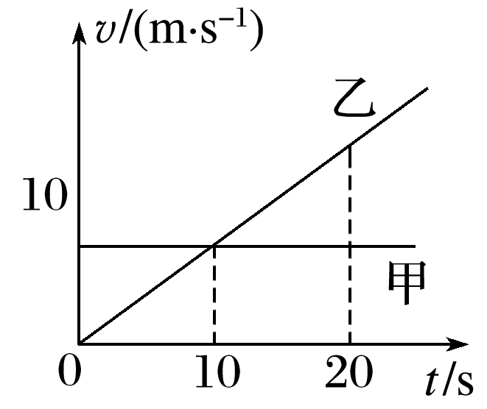
1．甲、乙两车在平直的公路上同时同地沿同一方向做直线运动，它们的v－t图像如图所示，在0～20 s这段时间内，下列说法正确的是( )
A．在t＝10 s时两车相遇
B．在t＝10 s时两车相距最近
C．在t＝20 s时两车相遇
D．在t＝20 s时，乙车在甲车前面

2．当交叉路口的绿灯亮时，一辆客车以a＝2 m/s² 的加速度由静止启动，在同一时刻，一辆货车以10 m/s的恒定速度从客车旁边同向驶过(不计车长)，则：
(1)客车什么时候追上货车？客车追上货车时离路口多远？
(2)在客车追上货车前，两车的最大距离是多少？

[课后作业]完成课后作业《追击与相遇问题》（建议作业时间为30分钟）
[课后感悟]____________________________________________________________________

________________________________________________________________________________

