Just as supplies of toilet paper are finally getting back to normal, the coronavirus has triggered another shortage of something we typically take for granted: pocket change.
Banks around the US are running low on nickels, dimes, quarters and even pennies. And the Federal Reserve, which supplies banks, has been forced to ration scarce supplies.
"It was just a surprise," said Gay Dempsey, who runs the Bank of Lincoln County in Tennessee, when she learned of the rationing order. "Nobody was expecting it."
Dempsey's bank typically dispenses 400 to 500 rolls of pennies each week. Under the rationing order, her allotment was cut down to just 100 rolls, with similar cutbacks in nickels, dimes and quarters.
That spells trouble for Dempsey's business customers, who need the coins to stock cash registers all around Lincoln County, Tenn.
"You think about all your grocery stores and convenience stores and a lot of people that still operate with cash," Dempsey said. "They have to have that just to make change."
Rural banks in particular seem to be getting shortchanged, according to Colin Barrett, CEO of the Tennessee Bankers Association.
Rep. John Rose, R-Tenn., sounded the alarm last week during a hearing before the House Financial Services Committee.
"My fear is that customers who use these banks will react very poorly," Rose said. "And I know that we all don't want to wake up to headlines in the near future such as 'Banks Out of Money.' "
The congressman warned that if businesses are unable to make exact change, they'll be forced to round up or round down, "in a time when pennies are the difference between profitability and loss."
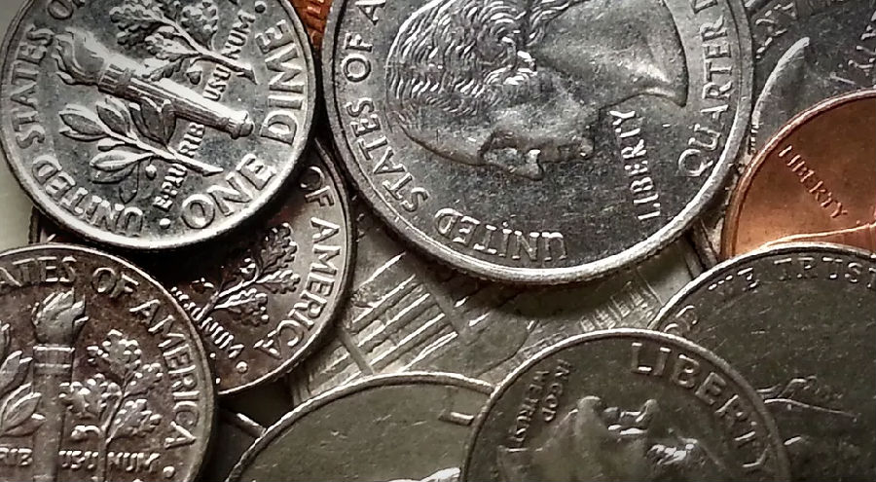
Federal Reserve Chair Jerome Powell assured Rose that the central bank is monitoring the situation closely.
"We're working with the mint to increase supply, and we're working with the reserve banks to get that supply where it needs to be," Powell said. "So we think it's a temporary situation."
The US Mint produced fewer coins than usual this spring in an effort to protect employees from infection. But the larger problem — as with many other pandemic shortages — is distribution.
During the lockdown, many automatic coin-sorting machines that people typically use to cash in loose change were off-limits. And with many businesses closed, unused coins piled up in darkened cash drawers, in pants pockets and on nightstands, even as banks went begging.
"The flow of coins through the economy ... kind of stopped," Powell said.
The Fed chairman stressed that this clog in the financial plumbing should clear quickly, now that businesses are reopening, and that supplies of coins should soon be back to normal.
In the meantime, Dempsey, the banker, has secured an emergency stash of coins from some of her business customers who run vending machines and laundromats.
While a growing number of people rely on credit cards or smartphone apps for many transactions today, the coin crunch is a reminder that sometimes you just need change.
"Cash is still king, I guess," Dempsey mused.
就在卫生纸供应总算恢复正常时，新冠肺炎疫情却引发了另一种我们想当然的东西短缺：零钱。
美国各地银行的五分硬币、十分硬币、两角五分硬币甚至还有一分硬币都出现短缺。给银行供应货币的美联储被迫限额配给稀缺硬币。
美国田纳西州林肯县银行的行长盖伊·邓普赛听说配额令后表示：“真是让人惊讶。没有人料到会这样。”
邓普赛的银行通常每周要发放400到500卷一分硬币。在配额令下，她分配到的一分硬币降到只有100卷，分配到的五分硬币、十分硬币和两角五分硬币也同样减少了。
这对邓普赛的企业客户来说意味着麻烦，这些企业客户需要硬币来装满田纳西州林肯县各地店铺的现金出纳机。
邓普赛说：“想想所有的杂货店和便利店，还有许多仍然用现金交易的人们。他们需要有硬币才能找钱。”
田纳西州银行家协会的首席执行官科林·巴瑞特说，乡村银行似乎尤其缺少零钱。
上周田纳西州共和党参议员约翰·罗斯在众议院金融服务委员会的一次听证会上敲响了警钟。
“我担心的是，这些银行的客户反应会很糟。我知道，大家都不想在不久的将来一早醒来，看到‘银行没钱了’这种头条新闻。”
这位参议员警告称，如果企业无法精确找零，他们将被迫四舍五入，“这可是一个零头能决定盈利还是亏损的时刻。”
美联储主席杰罗米·鲍威尔向罗斯保证，他表示央行正密切监控这个局面。
“我们正在和造币厂合作增加供应，也在和联邦储备银行合作，向需要的地方供应硬币。所以我们认为这是个暂时的情况。”
为了保护员工不被病毒感染，美国造币厂今年春天生产的硬币比往常少。但是和疫情引发的许多其他短缺一样，发放才是更大的问题。
在封锁期间，许多人们通常用来换零钱的硬币自动分类机被禁止使用。由于许多商店都关门了，大量闲置的硬币堆在黑暗的现金抽屉、裤子口袋和床头柜里，而银行却在四处讨要硬币。
鲍威尔说：“贯穿经济的硬币流通……几乎停止了。”
鲍威尔强调，如今企业正在重新开放，堵住的金融管道应该迅速清理，硬币的供应应该迅速回归正常。
与此同时，银行行长邓普赛已经从一些经营自动售货机和自助洗衣店的企业客户那里获得了一笔硬币存货来应急。
尽管越来越多的人依赖信用卡或智能手机应用来交易，这次硬币告急提醒了人们，有时候你还是需要零钱。
“现金仍然为王，我想，”邓普赛沉思着说。

