The coronavirus began to affect sporting events as early as January 30, when the Chinese Football Association announced it was delaying the start of the football season. Two months later it was revealed that the Tokyo Olympic Games would be postponed until the summer of 2021 – the first postponement in modern Olympic history.
Sporting administrators are only now exploring ways to enable a return to training and competition at both professional and amateur levels. In the absence of a vaccine, though, there are several challenges. One of them is around breathing.
When playing sport, breathing is faster and harder than at rest, which increases the risk of passing the disease on. As a result, premier league football is considering introducing face masks. Others may follow suit.
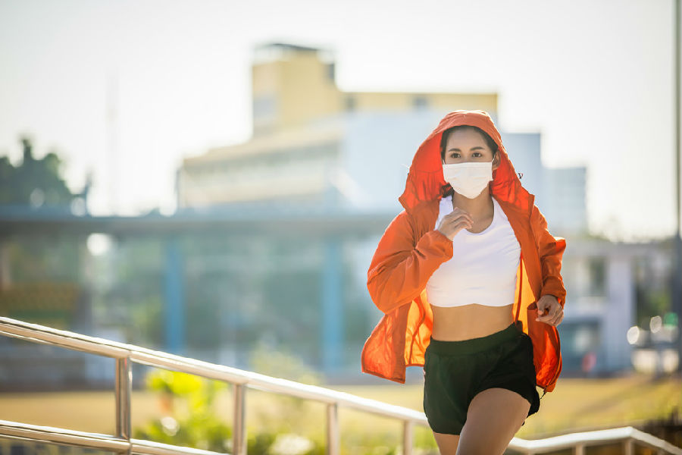
Yet a mask makes it harder to inhale the quantity of air needed to perform at the highest levels. We know that wearing a surgical mask can increase the resistance to airflow. Exercise invariably leads to faster and harder breaths, so wearing a mask during exercise places a further strain on airflow.
At low to moderate-intensity exercise, effort will feel slightly harder than normal with a mask, but you can still walk comfortably. The challenge appears to be more during heavy exercise (say, rugby or football) taking in air at rates of about 40-100 litres per minute.
When we do heavy exercise, our muscles produce lactic acid, which causes that burning sensation. It is then converted to carbon dioxide and exhaled. But what happens if the carbon dioxide is trapped by the mask? As you move from moderate to heavy exercise, you may be re-breathing carbon dioxide, which can reduce cognitive function and increase breathing rate.
There may also be less oxygen in the recycled air, which could imitate exercising at higher altitudes. So it is important we gain a better understanding of the limitations of heavy exercise with a face mask.
从1月30日开始，疫情就对体育赛事造成了影响，当时中国足球协会宣布推迟足球赛季的起始时间。两个月后东京奥运会也宣布推迟到2021年夏季召开，这是现代奥运史上第一次延期。
体育管理者现在试图鼓励专业和业余运动员恢复训练和竞赛。但由于缺乏疫苗，恢复体育运动还存在一些困难，其中就包括呼吸问题。
做运动时的呼吸比休息时更快更用力，会增加疾病传播的风险。因此英超足球正考虑引进口罩，其他人可能也会效仿。
但在运动量达到最大时戴口罩会使空气吸入量不足。我们都知道佩戴医用口罩会增加气流阻力。锻炼一定会导致呼吸更快更用力，所以运动期间佩戴口罩对气流会造成进一步的压力。
进行中低强度锻炼时会感觉比平时戴口罩时呼吸更费力，但你走路时依旧很舒服。做剧烈运动（如橄榄球或足球）时问题就更严重了，每分钟吸入空气量约为40-100升。
做剧烈运动时，我们的肌肉产生乳酸，会有灼热的感觉，然后转化为二氧化碳呼出。但如果二氧化碳被口罩挡住了会怎样？随着你的运动强度从中度到剧烈，你可能会重新吸入二氧化碳，这会降低认知功能，增加呼吸频率。
循环的空气中氧气可能变少，这就像是在高海拔地区做运动。所以重点是我们要更明白戴口罩做剧烈运动的限制。

